Could Priscilla be the author of Hebrews?

Points to Consider
- She was one of the 70 disciples listed in Luke 10.
- She was the teacher of Apollos, a teacher of teachers.
  - She was learned and well spoken.
- Her and her husband travelled and ministered with Paul (Rom 16:3)
- Priscilla and Aquila were Jewish Christians.
- The author seems to imply they never met Jesus (2:3). This eliminates a great number of the possible authors but not Priscilla, she was from Pontus (Northern Asia Minor).
- The NT in an unprecedent way explicitly makes it clear that Priscilla was the lead minister and that Aquila served as her assistant.
  - Priscilla’s name is listed 1st 5 out of the 7 times their names appear together.
- Some have argued Hebrews has a feminine voice.
  - “I appeal to you brethren, bear with my word…” (13:22)
- Hebrews includes many (some unusual) examples of women heroines.
- Throughout Hebrews the author favors the pronoun “we.” This would have been natural for Priscilla; both as a woman, and as a co-minister with her husband.
- The early church loosely assumed a Pauline authorship.
  - This is actually an argument in favor of Priscilla since as a student of Paul, her language, teaching and writing style would mirror his.
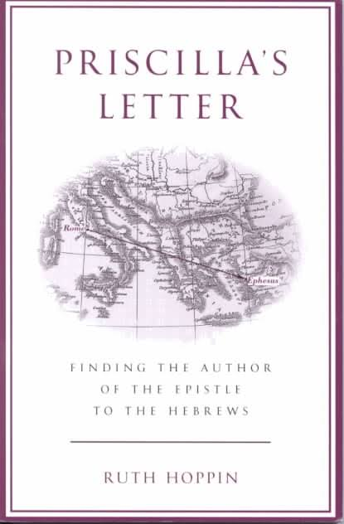
- Among 14,000 letters found in the NT world, Hebrews is the only one that lacks a greeting or at least the authors name.
  - Not including her name makes perfect sense in the patriarchal world of the NT.

For further exploration check out, Ruth Hoppin’s, “Priscilla’s Letter” ->

